Present Progressive vs. Simple Present - Cloze - 1
Directions: ​Complete the story with the correct ​present progressive ​or ​simple present​ tense of
the verb in parentheses.

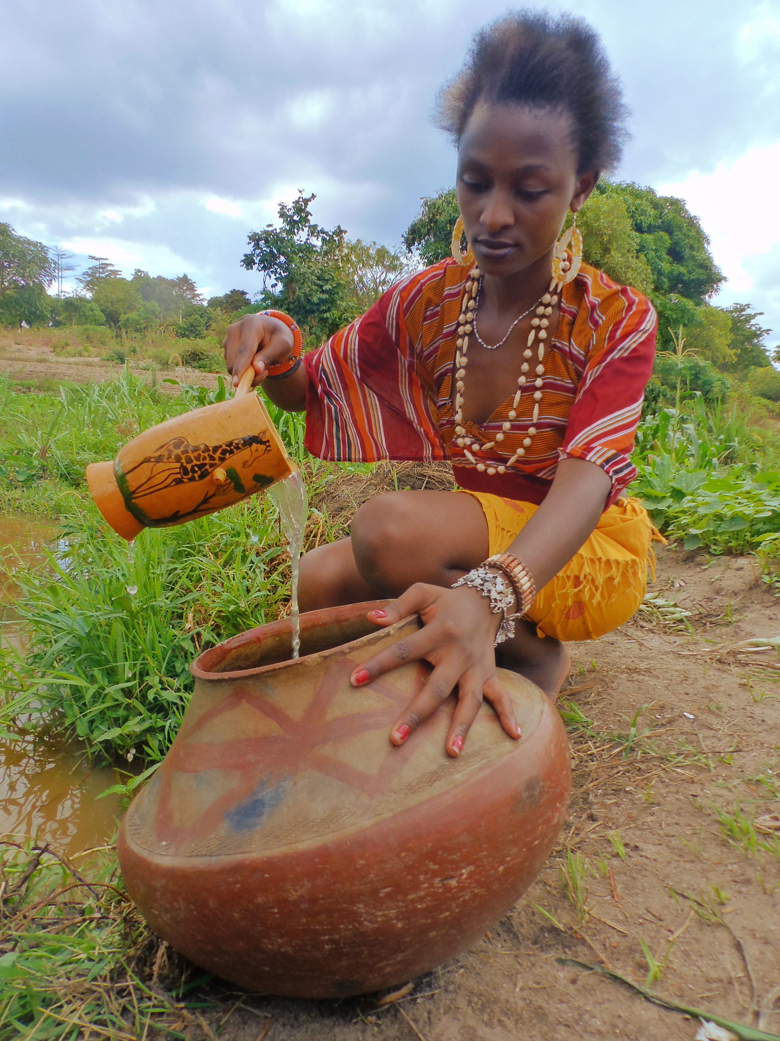

This is a picture of ​Almaz. He (1) ________ (be) from Tibet. Right now, she (2) _________ (sit) in the river and (3)_________(pour) water onto the bowl to clean it. The water (4) _________ (splash) off the bowl into the air. Washing the dishes (5) _________ (be) Almaz’s daily chore. Every day after lunch, she (6) _________ (go) to the river and (7) _________ (wash) the dishes. She (8) _________ (like) doing this chore because the water (9) _________(be) cool and relaxing. Today, she (10)_________ (wear) an orange robe. She (11) ________ (wear, negative) a hat because she (12) _________ (like, negative) them. Almaz (13)________ (live) near the river with her family. She (14) _________ (help) her family with the family work. She (15)_________ (have) a good life.

Simple Present / Present Continuous- Cloze-2

Today (be) .............. the second day of my trek around Mount Annapurna. I am exhausted and my legs (shake) ............; I just hope I am able to complete the trek. My feet (kill, really)............. me and my toes (bleed) .........., but I (want, still).......... to continue. Nepal is a fascinating country, but I have a great deal to learn. Everything (be) ............. so different, and I (try)........... to adapt to the new way of life here. I (learn).......... a little bit of the language to make communication easier; unfortunately, I (learn, not)............... foreign languages quickly. Although I (understand, not) ................. much yet, I believe that I (improve, gradually) ....................

I (travel, currently) ............... with Liam, a student from Leeds University in England. He (be) ............... a nice guy, but impatient. He (walk, always) ............. ahead of me and (complain)............ that I am too slow. I (do) .................. my best to keep up with him, but he is younger and stronger than I am. Maybe, I am just feeling sorry for myself because I am getting old.

Right now, Liam (sit)................. with the owner of the inn. They (discuss)................ the differences between life in England and life in Nepal. I (know, not) .................... the real name of the owner, but everybody (call, just)................. him Tam. Tam (speak) ................... English very well and he (try) ............... to teach Liam some words in Nepali. Every time Tam (say)............... a new word, Liam (try).............. to repeat it. Unfortunately, Liam (seem, also).............. to have difficulty learning foreign languages. I just hope we don't get lost and have to ask for directions.

Complete the passage with the correct form of the verbs in brackets. Use the Present Simple or Present Continuous.

If you ¹____________ (love) surfing and ²____________ (want) to get a university degree, you should go to Plymouth University in Britain. Students who ³____________ (surf) three or four times a week for fun can now do a degree in surfing, and make a career of it. While surfing ⁴____________ (look) easy when you watch from the beach, getting a degree is quite hard to achieve. Jim and Helen are in their last year of school, and ⁵____________ (take) their A-levels this summer. They both ⁶____________ (own) surfboards, but they ⁷____________ (not surf) much these days. They ⁸____________ (study) very hard for their Alevels. They ⁹____________ (know) the academic requirements for acceptance to the surfing course are high, and the course itself is also hard. It ¹⁰____________ (include) oceanography, marine biology, ecology and the design of wetsuits and surfboards, as well as actual surfing. But Jim and Helen both ¹¹____________ (believe) it’s worth the effort. Let’s wish them luck.

